

Project Title:
AI Tweet Verification System
Group members:
Hafsa Shaikh.
Alina Ali.
Muhammad Suleman.
- Supervisor:
Ma’am Muniza Memon.

Abstract:
This project analyzes tweets using Artificial Intelligence techniques to classify them into positive, negative, or neutral categories. The tweets are first cleaned and preprocessed, then converted into numerical form using TF-IDF. A machine learning model is trained to predict sentiment from the data. The system helps in understanding public opinion from social media efficiently
Introduction:
Media platforms such as Twitter (X) generate a large amount of textual data every day in the form of tweets. These tweets contain users’ opinions, emotions, and feedback about various topics such as products, events, and public issues. Due to the massive volume of data, manual analysis is not practical or efficient.
To solve this problem, Artificial Intelligence (AI) and Natural Language Processing (NLP) techniques are used to automatically process and analyze text data. One of the most common applications of NLP is sentiment analysis, which classifies text into positive, negative, or neutral sentiments.
- Twitter generates large-scale unstructured text data (tweets).
- Manual analysis of tweets is time-consuming and inefficient.
- AI and NLP techniques help in automated text analysis.
- Machine learning models can predict tweet sentiment automatically.

Problem Statement:
- The Growing Problem of Misinformation on X (Twitter) and the need for Automated Detection.
- INFORMATION ABOUT X(TWITTER):
- Around 557 million users (2026 estimate),
- 237.8 million people use X (Twitter) daily (as per 2022 report)
- Around 63.7% males and 36.3% females use X.
- The average age of X users is between 25 and 34.
- Source link https://www.demandsage.com/twitter-statistics
Real Life incidents caused by Misinformation Tweets.
Misinformation containing tweets that lead to severe consequences have increased tremendously on X (Twitter), a widely used social media platform.
- Pizzagate child trafficking Conspiracy in US, leaded to real life violence.
- United States election misinformation Tweets leaded to political unrest and consequence was United States Capitol attack on January 6, 2020.
- COVID-19 fake cure Tweets (2020), misguided people to drink bleach, random medicines etc as a precautionary measure that reported several deaths.

Methodology:
Datasets used:
- Collection of real and fake tweet datasets used for training the model.
- Real Tweet Dataset: Fake Tweet Dataset:
  - 1. true12.csv 3. Fake.csv
  - 2. true1234.csv 4. fake1.csv
Model Files
- Trained Naive Bayes model and TF-IDF vectorizer .
- Saved machine learning model (model.pkl)
- Text converter (vectorizer.pkl) used for prediction.
GUI Application
- Interactive interface for real-time tweet classification using Tkinter library.

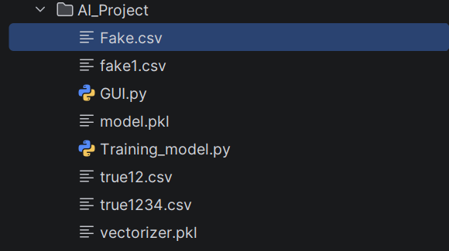
Tools and Technologies Used
- Python (Programming Language)
- Pandas (Data handling and CSV reading)
- NumPy (Numerical operations)
- Regular Expressions (Text cleaning)
- Scikit-learn (Machine Learning library)
- Pickle (Model saving and loading)
Results
- The system successfully classifies text into REAL and FAKE categories
- Provides probability-based predictions
- Handles uncertain cases using threshold logic
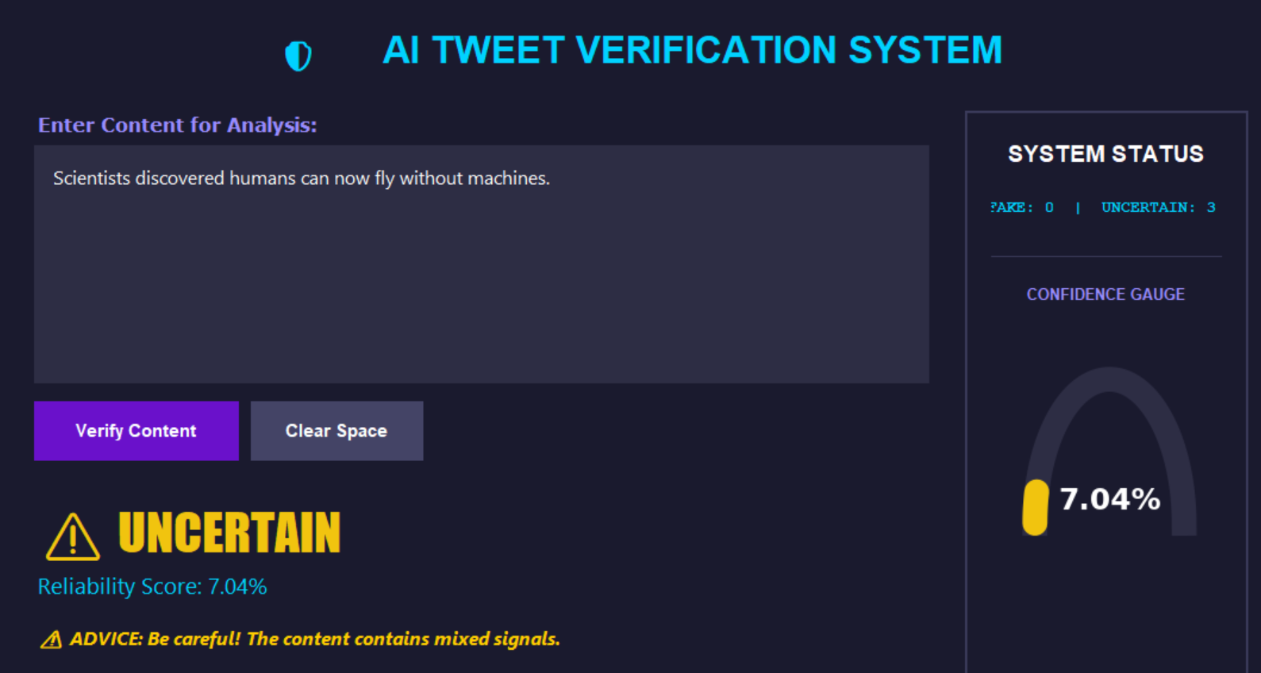
- Achieves reliable accuracy on test datase

